DATA HANDELLING AND VISUALISATION ASSIGNMENT 3
“Analysis of GDP per Capita and Life Expectancy”
Lee Ling Jun 339JIYDY
Abstract –

Introduction

Background & Motivation
Over the past two centuries, countries have experienced dramatic improvements in both economic output and population health. As economies industrialise and incomes rise, people generally gain better access to nutrition, sanitation, healthcare and education, all of which can contribute to living longer, healthier lives. However, these improvements have not been evenly distributed: some high-income countries still struggle with relatively poor health outcomes, while a few middle-income countries achieve surprisingly long life expectancy. Understanding how closely economic prosperity and longevity move together—and where they diverge—is important for policymakers deciding how to prioritise investments in health systems and wider social development. This project is motivated by the need to visualise and quantify that relationship using historical, country-level data.

Research Question & Objectives
The central research question for this project is: How does GDP per capita relate to life expectancy across countries and over time? From this, several more specific objectives follow:

- To describe long-run trends in both GDP per capita and life expectancy at birth at the global level.
- To examine the cross-sectional relationship between income and life expectancy in recent years, including whether a log transformation of GDP provides a clearer association.
- To compare life expectancy outcomes across income groups and identify countries that over- or under-perform relative to what would be expected given their GDP per capita.
These objectives guide the choice of variables, preprocessing steps, statistical analysis and visualisations used in the rest of the report.

Scope of the Analysis
The analysis focuses on country-level annual data combining GDP per capita from the Maddison Project with period life expectancy estimates at multiple ages. For clarity and comparability, the core outcome variable is life expectancy at birth, while GDP per capita (in constant international dollars) is used as the main measure of economic development, with additional transformations such as log(GDP per capita) and GDP growth where relevant. The time span is restricted to the period from 1800 to 2020, where overlapping data coverage is sufficiently strong for both datasets. The study is descriptive and exploratory rather than causal: it aims to characterise patterns and associations, not to prove that income directly causes changes in life expectancy. Other potentially important determinants—such as inequality, conflict, or health-system quality—are acknowledged but not modelled explicitly within the current scope.

Dataset Overview

Dataset Source & Accessiblities
This project combines two openly accessible country-level time-series datasets: one on economic output and one on life expectancy.
- GDP per capita data are taken from the Maddison Project Database (latest available release), which provides historical estimates of GDP per capita in constant international dollars for a large set of countries over several centuries. The dataset is publicly available for download via Our World in Data at:
https://ourworldindata.org/grapher/gdp-per-capita-maddison-project-database
- Life expectancy data are drawn from an Our World in Data dataset containing period life expectancy estimates at multiple ages (0, 10, 15, 25, 45, 65 and 80) by country and year. This dataset is also openly available and can be accessed through the OWID data explorer and downloads section, for example via:
https://ourworldindata.org/grapher/rleada
Both sources are distributed under open licences that permit academic use, downloading and local processing. The datasets were downloaded as CSV files and stored in the project’s data/raw directory, then merged and cleaned in Python before analysis.

Key Variables and Structure

Data Format
GDP per Capita
Feature | Description
Year | Calendar year of measurement. Dataset is annual time-series.
Entity | Country or region name (e.g. Afghanistan, Spain, United Kingdom).
Code | ISO-3 country code used to uniquely identify each Entity.
Year | Calendar year of measurement. Dataset is annual time-series.
GDP per capita | Gross Domestic Product per person, measured in constant international dollars. This represents economic output adjusted for population size and inflation, making it comparable across countries and over time.
900793-annotations | Auxiliary metadata column (mostly empty). Contains annotation flags used internally by the source organisation. Not used for modelling or analysis.
Figure 1. Features in GDP per capita dataset
The GDP per capita dataset contains annual country-level economic output figures expressed per capita, allowing comparisons across countries independent of total population size. The values are inflation-adjusted (constant international dollars), enabling meaningful comparisons over time. Apart from the main variable, the dataset also includes a mostly empty annotation column, which can be ignored for analysis purposes.

Life expectancy
Feature | Description
Entity | Country or region name (e.g. Afghanistan)
Code | ISO-3 country code
Year | Calendar year of observation
Life expectancy variables (7 columns) | Period life expectancy measures at ages 0, 10, 15, 25, 45, 65, 80 — expected remaining years of life at each age, averaged across sexes
Figure 2. Features in Life expectancy dataset
The Life Expectancy dataset is organised at the country–year level, identified by Entity (country name), Code (ISO-3 code), and Year. The main information is provided through seven life-expectancy variables, which report period life expectancy at ages 0, 10, 15, 25, 45, 65 and 80. Each value represents the expected remaining number of years a person would live if they are currently at that age, based on the mortality rates of that specific year, and averaged across sexes.Data Preprocessing

Merging data sets

Cleaning and Transformation of variables

Handling Missing values and outliers

Engineered Features
Log GDP, growth LE indices

Exploratory Data Overview

Descriptive Statistics
GDP Per Capita
Feature | Count | Mean | Std. deviation | Min | 25% (Q1) | 50% (Median) | 75% (Q3) | Max
Year | 21,586.00 | 1,885.58 | 173.4193 | 1 | 1,865.00 | 1,957.00 | 1,991.00 | 2,022.00
GDP per capita | 21,586.00 | 6,869.64 | 10,723.73 | 295 | 1,470.00 | 2,617.94 | 7,231.69 | 160,051.23

Figure 1. Descriptive statistic of raw data set in GDP per capita dataset
The descriptive statistics show that the GDP per capita variable has a very wide range across the dataset. GDP per capita values span from as low as 295 USD up to over 160,000 USD per person, indicating extremely large differences in economic output between countries and/or time periods. The mean is around 6,870 USD, but the standard deviation is high (10,723), which confirms that the distribution is highly spread and likely right-skewed due to wealthy countries. The Year variable ranges from 1 to 2022, reflecting the large historical time coverage of the GDP dataset. Overall, these statistics highlight that economic development varies dramatically across countries, and this variation is substantial enough to examine how it relates to life expectancy patterns.

Life Expectancy
Feature | Count | Mean | Std. Dev | Min | 25% (Q1) | 50% (Median) | 75% (Q3) | Max
Year | 20,804 | 1980.03 | 32.95 | 1751 | 1964 | 1984 | 2004 | 2023
Life expectancy – Age 0 | 20,804 | 62.74 | 12.32 | 10.99 | 54.18 | 65.19 | 72.23 | 86.37
Life expectancy – Age 10 | 20,804 | 59.04 | 7.08 | 10.23 | 53.93 | 59.69 | 64.05 | 76.80
Life expectancy – Age 15 | 20,804 | 54.43 | 6.75 | 6.93 | 49.54 | 54.94 | 59.17 | 71.82
Life expectancy – Age 25 | 20,804 | 45.66 | 5.91 | 4.73 | 41.33 | 45.86 | 49.71 | 61.91
Life expectancy – Age 45 | 20,804 | 28.68 | 4.10 | 3.60 | 25.66 | 28.30 | 31.22 | 42.16
Life expectancy – Age 65 | 20,804 | 13.82 | 2.54 | 3.01 | 11.96 | 13.32 | 15.21 | 23.21
Life expectancy – Age 80 | 20,804 | 6.111352 | 1.299647 | 2.0474 | 5.210675 | 5.8054 | 6.74105 | 11.8156
Figure 1. Descriptive statistic of raw data set in GDP per capita dataset
The descriptive statistics show that life expectancy increases consistently with age, as expected from period life-table structure. At birth (Age 0), the average life expectancy in the dataset is approximately 62.7 years, with values ranging from about 11 years up to over 86 years, reflecting large differences across countries and historical periods. As the starting age increases, the remaining expected lifespan decreases accordingly — for example, at age 45 the average remaining life expectancy is 28.7 years, and at age 80 it is 6.1 years on average. The relatively small standard deviations at older ages (compared to age 0) suggest that cross-country variation becomes narrower later in life, whereas the broad spread at younger ages indicates larger differences in child mortality and general living conditions. The year variable ranges from 1751 to 2023, indicating that this dataset covers a long historical period, allowing for long-term trend analysis.

Missing Data
GDP per Capita
Features | Missingness (%)
900793-annotations | 99.87
Code | 1.26
Entity | 0
Year | 0
GDP per Capita | 0

Life Expectancy
Features | Missingness (%)
Code | 9.3
Entity | 0.0
Year | 0.0
Life expectancy - Sex: total - Age: 0 - Type: period | 0.0
Life expectancy - Sex: total - Age: 10 - Type: period | 0.0
Life expectancy - Sex: total - Age: 15 - Type: period | 0.0
Life expectancy - Sex: total - Age: 25 - Type: period | 0.0
Life expectancy - Sex: total - Age: 45 - Type: period | 0.0
Life expectancy - Sex: total - Age: 65 - Type: period | 0.0
Life expectancy - Sex: total - Age: 80 - Type: period | 0.0

The missingness analysis shows that both datasets are generally very complete for the key analytical variables. In the GDP per capita dataset, the only substantial missingness is in the 900793-annotations column (≈99.9%), which is a metadata field and not required for the analysis. The core fields Entity, Year, and GDP per Capita have no missing values, while Code is missing for only about 1.3% of rows, which is unlikely to affect results materially. The Life Expectancy dataset is even more complete: all life expectancy variables across ages (0, 10, 15, 25, 45, 65 and 80) have 0% missingness, and Entity and Year are also fully populated. Only the Code field has some gaps (around 9.3%), but since countries can still be uniquely identified using the Entity name, this level of missingness does not pose a major problem for merging or analysis.

Data Quality

Data Licensing and Citation

Visual Analysis And Findings

Trends Income and Longevity
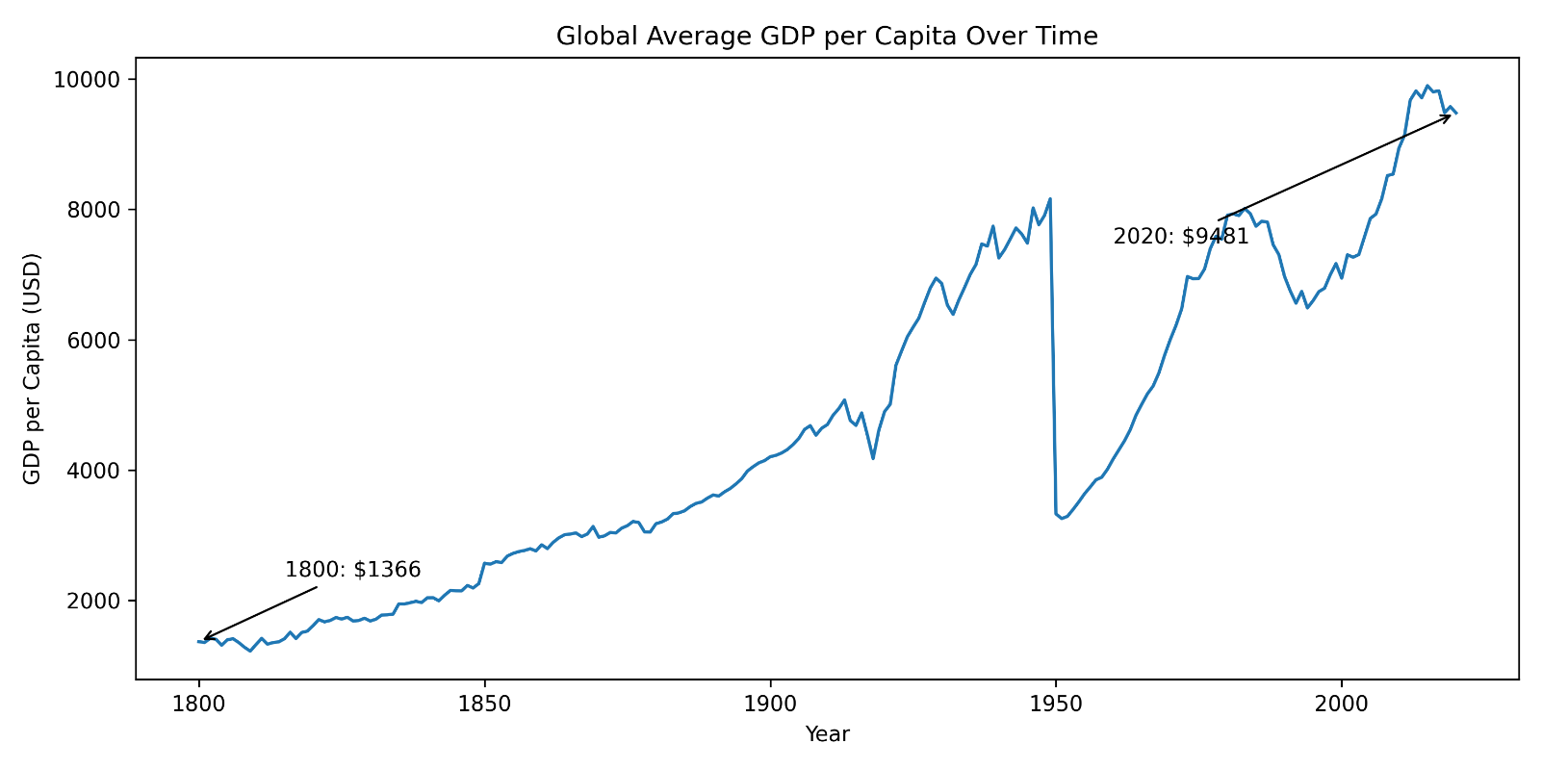
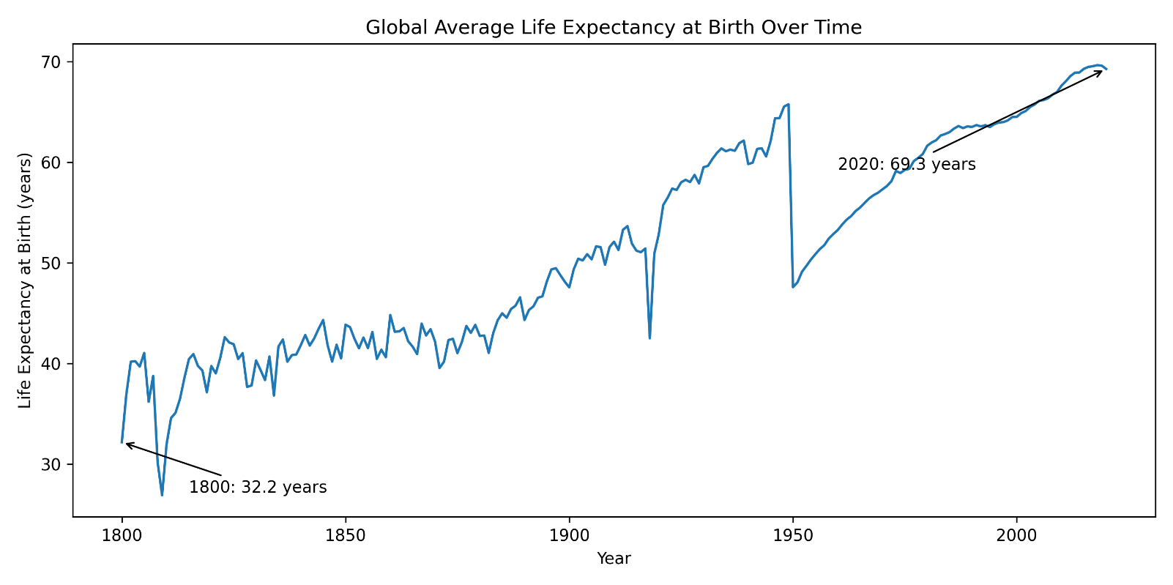
The two line charts of global averages show that both GDP per capita and life expectancy at birth have increased substantially over the period 1800–2020. Global GDP per capita rises slowly through the nineteenth century, accelerates in the twentieth century, and reaches close to 10,000 USD in recent years, with temporary slowdowns and dips around major historical disruptions. The life expectancy series follows a similar long-run upward trajectory: global life expectancy at birth increases from a little over 30 years in the early 1800s to around 70 years today. The most rapid gains occur after the mid-twentieth century, when improvements in public health, medicine and living standards spread more widely. Taken together, these trends indicate that, at the global level, economic development and longevity have improved in tandem over the last two centuries.

Cross-Sectional Relationship Between GDP and Life Expectancy
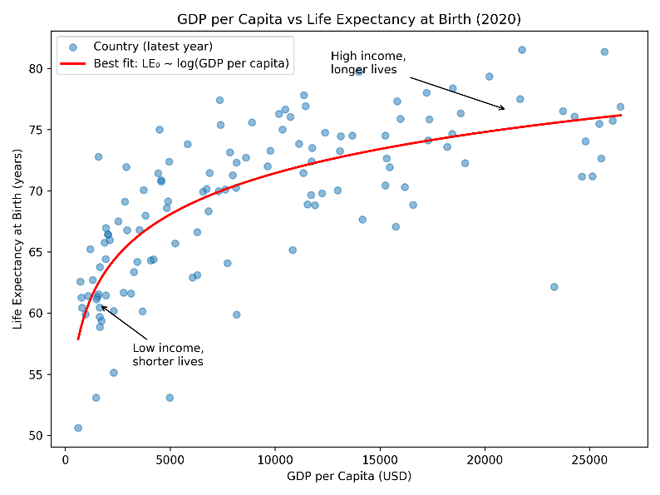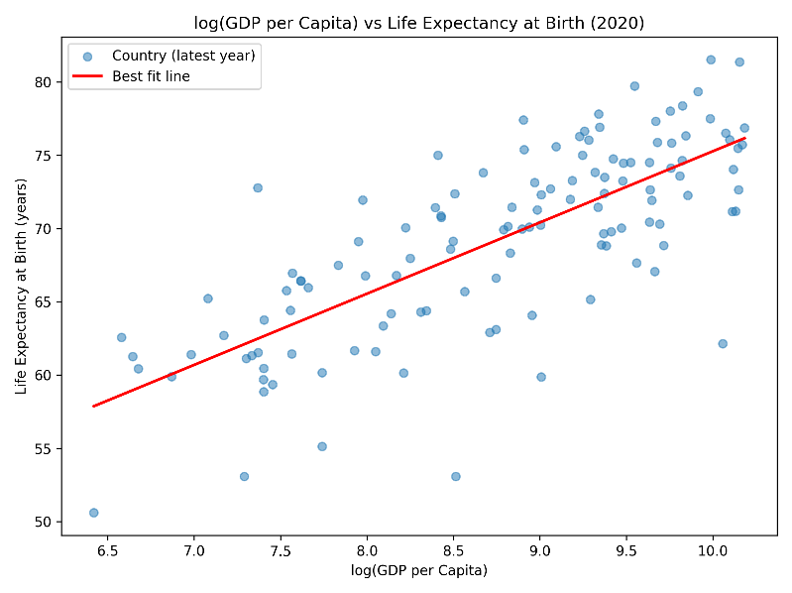
The cross-sectional scatter plots for the most recent year show a clear positive association between income and longevity. When GDP per capita is plotted directly against life expectancy at birth, most low-income countries cluster in the bottom-left region with both low income and low life expectancy, while high-income countries appear in the upper-right with higher income and longer lives. However, the relationship is curved: large increases in GDP at high income levels correspond to relatively small gains in life expectancy. When GDP per capita is log-transformed, the pattern becomes closer to a straight line, indicating that proportional (rather than absolute) differences in income are more informative. This supports the idea of diminishing returns: income matters most for life expectancy at low and middle levels of development, while very rich countries gain fewer additional years from further income growth.

Life Expectancy Differences Across Income Groups
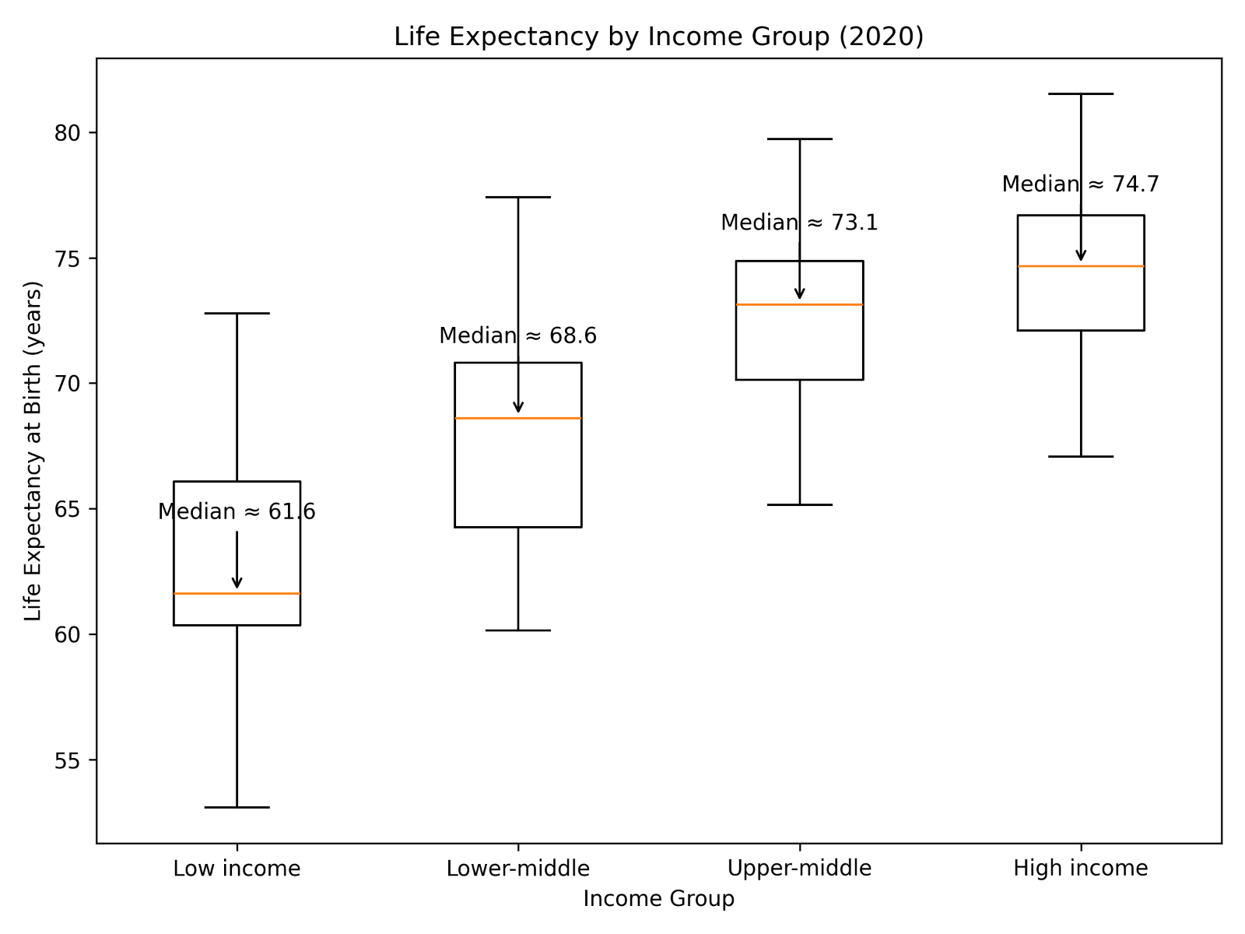
The boxplot of life expectancy at birth by income group (for 2020) summarises these cross-sectional patterns in a compact way. Moving from low-income to high-income groups, the median life expectancy rises steadily, from the low 60s in low-income countries to the mid-70s in high-income countries. The spread of outcomes is also widest in the low-income group, where some countries achieve relatively high longevity while others remain far behind, indicating large within-group inequality. By contrast, the upper-middle and high-income groups show higher medians and narrower interquartile ranges, suggesting that once countries reach these income levels, life expectancy is both higher and more homogeneous. Overall, the boxplot highlights a clear income gradient in health outcomes, with substantial but not unlimited gains in life expectancy as countries move up the global income distribution.

Country Trajectories in Income and Longevity
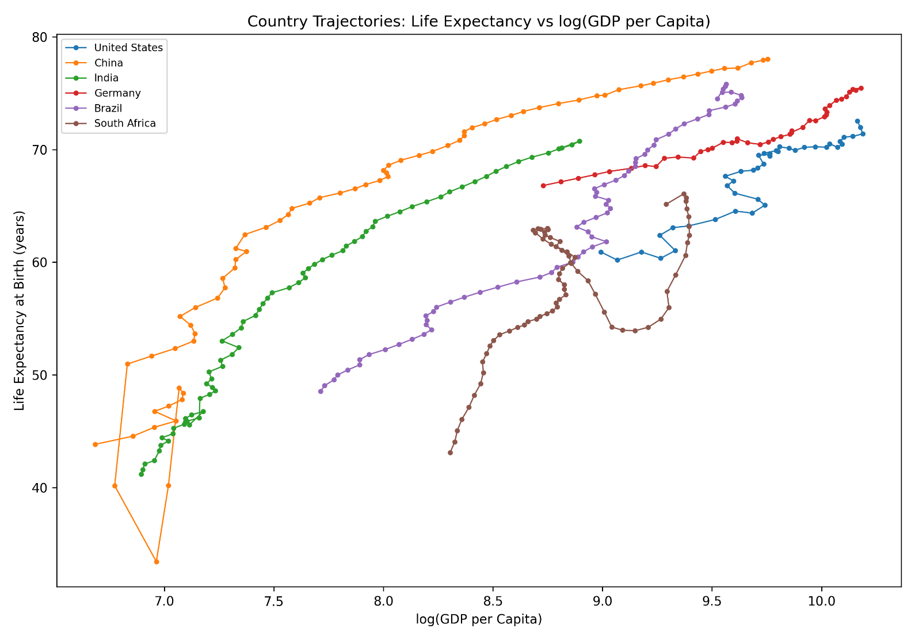
The trajectory plot maps the evolution of selected countries in the space of log (GDP per capita) and life expectancy at birth over time. Each country’s path traces how its income and longevity have co-evolved rather than showing only a static snapshot. For countries such as China and India, the trajectories start in the low-income, low-life-expectancy corner and move steadily upwards and to the right, reflecting rapid economic growth accompanied by large gains in life expectancy. Germany and the United States begin at higher income levels and show more gradual improvements in longevity, with periods of slowdown or modest reversals, consistent with already high starting points. Brazil and South Africa exhibit more irregular paths, with phases where income grows faster than life expectancy or where life expectancy stagnates despite changes in GDP. These differing trajectories illustrate that, while the long-run association between income and longevity is positive, the pace and balance of economic and health progress can vary substantially across countries.
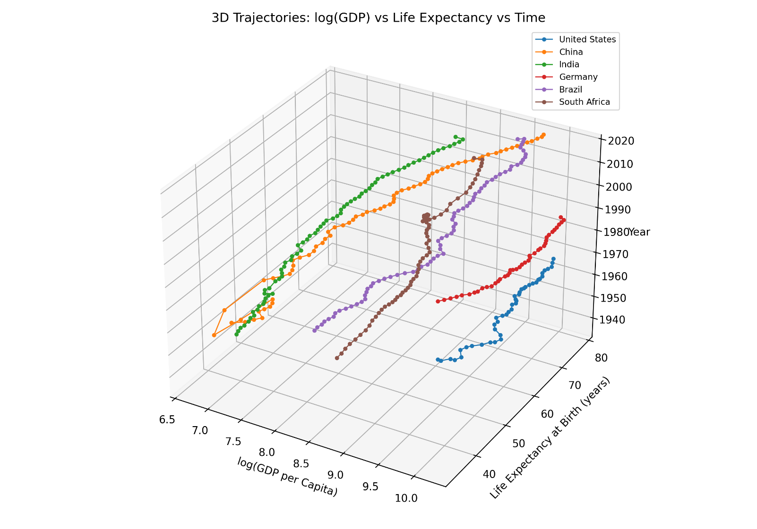

Regression and Outliers in GDP – Life Expectancy
Statistic | Value
Dependent variable | LE_0
Model | OLS (Least Squares)
Number of observations | 2,715
R-squared | 0.609
Adjusted R-squared | 0.609
F-statistic | 4,221
Prob (F-statistic) | 0
Log-likelihood | -8,369.40
AIC | 16,740
BIC | 16,754
Covariance type | non robust

Variable | Coef | Std. Error | t-value | p-value | 95% CI (lower) | 95% CI (upper)
const | 10.6736 | 0.879 | 12.138 | 0 | 8.949 | 12.398
log_GDP_pc | 6.5593 | 0.101 | 64.97 | 0 | 6.361 | 6.757

The OLS regression models life expectancy at birth (LE_0) as a function of log GDP per capita. The model explains around 61% of the variation in life expectancy across country–year observations (R² = 0.609), which is relatively high for cross-country social data and indicates a strong association between income and longevity. The estimated intercept is about 10.7 years, while the coefficient on log(GDP per capita) is approximately 6.56 and highly statistically significant (p < 0.001). This implies that a substantial proportional increase in income (for example, moving from a much lower to a much higher log GDP per capita) is associated with an increase of several years in expected life span. However, the R² being below 1 and the presence of sizeable residuals also show that GDP alone does not fully determine life expectancy; other factors such as health systems, inequality, conflict, and public policy likely play an important role in explaining remaining differences between countries.

Discussion

Trends (Time series Visualisation)

Top Emitters Analysis (Bar Chart Visualisation 2)

Life Expectancy s GDP Relationship (Time series Visualisation)

Summary Statistics Tables

Conclusion

Interpretation of Results

Limitations of Data & Methods

Implications and Policy/Economic Context

References

Summary of Key Findings

Potential Future Work / Further Data Sources

Appendix

GitHub Repository Link

Additional 3D Visualisations

Extra Country-Specific Plots

Full Correlatino Matrices/Regression Output

